$$documentTitle$$

What is WebRatio
WebRatio is a trusted MDD environment for building pure Java business Web applications, with no proprietary run-time. Models are based on BPMN, the standard notation for defining Business Processes, and WebML, a visual and intuitive DSL specifically designed for designing Web applications.

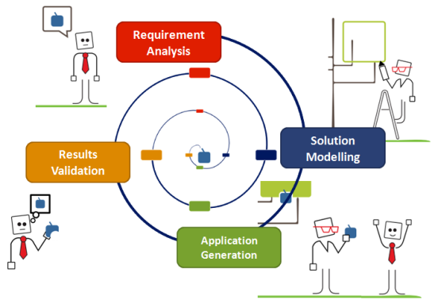
The Evolutionary Prototyping Development Cycle
$$developmentCycle$$

Features
$$featureName1$$ | $$featureDescription1$$
$$featureName2$$ | $$featureDescription2$$

Pricing
$$pricing$$

The WebRatio approach to BPM: build custom BPM applications
Instead of offering a whole platform comprehensive of all the typical features of a BPMS, WebRatio clearly distinguishes between design-time features and run-time features. At design-time WebRatio offers you a powerful modelling and development environment, allowing you to define all the requirements of your BPM project by capturing them in abstract models and custom components. At run-time, starting from the models, WebRatio generates a standalone custom BPM application that can be easily deployed on any standard Java Application Server.
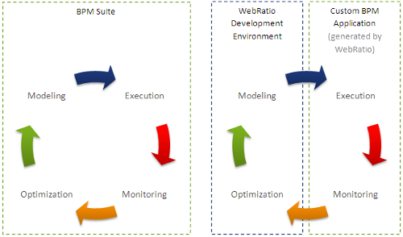
The development process of a BPM project with WebRatio is highly iterative. We call it “evolutionary prototyping development cycle”. At any stage of your project, even after a few minutes, you can generate the BPM application and test it immediately. In such way you will have an immediate feedback of what you have done and you can react accordingly. This kind of development process allows you to involve (if you want) your business users or your stakeholder in the evaluation of the work in progress.
WebRatio – Think it, Get it!

